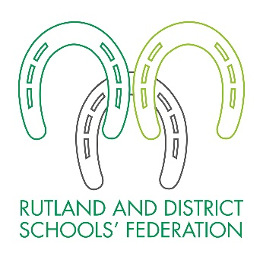
FREE SCHOOL MEALS
AND PUPIL PREMIUM

We need information about you and your child, so that we can provide them with the best education and support by making sure that the school receives all the government funding to which it is entitled. Please complete this form and return to the finance team at Rutland and District Schools’ Federation.

ABOUT YOUR CHILD/CHILDREN

Child’s Last Name | Child’s First Name | Child’s Date of Birth |  |  | Name of School
 |  | D D | M M | Y Y Y Y
 |  | D D | M M | Y Y Y Y
 |  | D D | M M | Y Y Y Y
 |  | D D | M M | Y Y Y Y

PARENT/GUARDIAN DETAILS

 | Parent/Guardian 1 |  |  |  |  |  |  |  |  |  |  |  |  |  |  |  |  |  |  |  | Parent/Guardian 2
Last name
First Name
Date of Birth | D D |  |  |  |  |  | M M |  |  |  |  |  | Y Y Y Y |  |  |  |  |  |  |  | D D |  |  |  |  |  | M M |  |  |  |  |  |  | Y Y Y Y
National Insurance Number*
National Asylum Support Service (NASS) Number* |  |  |  | / |  |  |  |  |  |  | / |  |  |  |  |  |  |  |  |  |  |  |  | / |  |  |  |  |  |  | /
Daytime Telephone Number
Mobile Number
Email address
Address | Postcode: |  |  |  |  |  |  |  |  |  |  |  |  |  |  |  |  |  |  |  | Postcode:
* Complete as appropriate
FAMILY INCOME AND BENEFIT DETAILS

You will be entitled to Free School Meals if any of these benefits qualify towards the household income.

- Income Support
- Income-based Jobseekers Allowance
- Income-related Employment and Support Allowance
- Support under Part VI of the Immigration and Asylum Act 1999
- The guarantee element of State Pension Credit
- Child Tax Credit (provided you are not entitled to Working Tax Credit) with an annual income of no more than £16,190
- Working Tax Credit run-on – Paid for 4 weeks after you stop qualifying for Working Tax Credit
- Universal Credit – your household income must be less than £7,400 a year (after tax and not including any benefits you get).

Please provide evidence of your total household income. (Please only provide copies, as we need to retain the paperwork as evidence).

DECLARATION

The information I have given on this form is complete and accurate. I understand that my personal information is held securely and will be used only for the determination of a Free School Meals and Pupil Premium application. I agree to notify Rutland and District Schools Federation in writing of any change in my family’s financial circumstances as set out in this form.

Signature of parent/guardian: ………………………………………………………….
Date:……………………….

*Applications will be processed within 10 working days, successful applications will be notified via email.
ABOUT THIS FORM

From September 2014 all children who are in reception, year 1 or year 2 in a state-funded school were offered a free healthy school lunch. Children in other school years will also be offered a free school lunch if their parent is receiving any of the welfare benefits listed overleaf.

Registering could raise money for your child’s school

Registering for free meals will raise extra income for your child’s school, to fund valuable support like extra tuition, additional teaching staff or after school activities.

This additional money is available from central government for every child whose parent is receiving one of the welfare benefits listed in the form. It is therefore important to sign up for free school meals, even if your child is in reception, year 1 or year 2.

