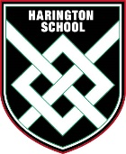
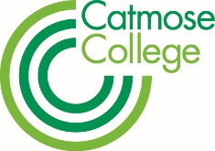

Catmose College and Harington School Transport Application 2020/2021

This application form is a contract between you and the College/School. By signing this form you are committing to the costs of the service for the full year, refunds are not given. Your transport space will be withdrawn if payment deadlines are not met.

If you have more than one student requiring transport, please complete a form for each student.

Please submit this form by 26 June 2020, at the latest. If you have any queries, please email Emma Dilks, (Bursar) edilks@catmosecollege.com.

Name of Student: …………………………………………………..………..……..………………………………………

D.O.B: …………………………………….……………….…….………….………………………….

Home address: ………………………………………………………………………………………………………………………………………………………………………………………………………………………………………………………………………………………………………………………………………

Post Code: ……………………………………………………………………………………..………

Year Group for Year 2020/21: (Please tick one option as below)

Year 7
Year 8
Year 9
Year 10
Year 11
Year 12
Year 13

Please tick bus route required:
RDSF1 (Melton Mowbray)
RDSF2 (Uppingham and villages)

Please tick permit type required:

Permit Type: Full

Part AM PM

(The cost will be £630 for a full permit and £365 for a part permit).

Information only at this stage: Payment can be made via Parent Pay:
- In full by 25th September 2020 a discount can be applied reducing the cost to £600.

- Alternatively spread the costs into smaller weekly or monthly payments providing the deadlines below are met.
£315.00 (Part Permit £185) due by 31st December 2020
£315.00 (Part Permit £180) due by 30th April 2021

Parent/Guardian email address: ……………………..…………………………….………………..

Form Completed By ……………………………………….…………………………………………..
Relationship to student…………………………………….……………………………………………

Date…………………………………………..………………………………………………………….

